Team Project: Group Report

# Abdala Ahmed, Akber Ali, Sabaa Fatani, David, Subdoh

Contents

Group Member Names 1

List of Figures 3

Project Team 5

Introduction 6

Project Requirements 6

Project Plan 7

Spider Diagram 7

Website Design 8

Website Design v0.2 9

Final Website Design 10

Website Structure 11

Database Structure 12

Project Components 15

[Payment] – [Sabaa Fatani] 15

[Loyalty Scheme] – [Sabaa Fatani] 15

Project Documentation 15

[Project Role] – [Name of the Person Responsible] 16

Group Activities 16

ConclusionReferences 17

Appendix A 19

# List of Figures

List of figuresAbstract

This section should describe your project detailing the functionality you have achieved and the motivation behind the project.

The motivation behind the project is to provide a means of purchasing products and services for customers, with the aim of making the process easier for the user. Which brought us to the conclusion of designing a Supermarket based website. The functionality of the application must enable the user to select a product and place it in the basket, in which the user would later proceed with check out.

# Project Team

This section should present the project team, their specific roles within the team and their responsibilities in terms of the software component they were responsible for the development of.

The team is made up of five members each with their own roles and responsibilities. The members are Abdala, Akber, Sabaa, Subdoh and David.

Abdala was responsible for keeping a log of meetings as well as a primary researcher for the team in terms of resources. In addition to this, he was also responsible for the registration form and login page in terms of the core development of the project.

Sabaa was responsible for the database structure and website structure, in terms of the core design. Furthermore, he was responsible for the link between the database and the website, in terms of how the website would extract the content from the database and display it on the website.

Akber’s role was team leader, and as such he was responsible for keeping track of the team members progress in terms of whether or not their carrying out their assigned tasks. Simply put, the team leader is what unifies the team, as well as a checkpoint to ensure that the tasks are completed by the set deadline.

# Introduction

The software we have created is an application which runs in a web browser it is a website. Designed to be used as an online checkout tool for a super market e.g. where buyers must register, then top up their account via credit card system. Then the buyer can browse products and choose to add specific quantities to the cart which will be showing the total as they go along. A buyer also has been shown to use product promotions and multibuy offers such as promo codes etc. when they reach the checkout they can see the total and see any discounts they receive and then pay for the items.

The software consists of four components, which are Marketing, Payment, Supplier and loyalty Scheme.

We achieved a fully functional website where a user can register top up their account, then go browsing through the different things that are for sale from a range of food to electronics, they can add the products to the cart and the cart will total up and show the total price in which they can buy the product.

The supplier side can log on with the special account and can view product quantity real time and can therefor order more stock to keep the supply running.

Marketing can check receipts and see what things have been purchased and see what things have not been sold, so they can put an offer on the main display page.

There is a contact page, user can see previous transactions in the form of receipts. We have also implanted the use of a loyalty scheme, where when each pound you spend you get points, and when the accumulate you can use it against the shopping.

The process we followed in the development of this website, firstly we choose the roles and who would carry out what task . Then we distributed the core development amongst out selves

the process you have followed.

It is important that you distinguish among different components such as the Core, Payment, Supplier interface etc. at this stage as this will then help you keep the rest of the document concise and structured.

# Project Requirements

Requirements of the overall project. This can be obtained from the case study provided as part of the assessment as well as other methods such as brainstorming and interviewing stakeholders. It is envisaged to have been gathered by the project manager for the overall project.

The aim for the project is to provide an online supermarket which serves as a means for customers to shop from home instead of having to go to the actual supermarket. The online supermarket simply enables the customer to select a product and drop it into the shopping cart/basket, in which the customer then checks out (pays for the goods).

Th requirements for the project are to include a registration form, which must be included for the customer to login, and thus have access to the online supermarket.

Another requirement is to include a supplier interface, in order to re-stock products that are running low, as well as ensure that there are enough products in the online supermarket.

In addition to this, another requirement is to include a loyalty scheme, which provides customers with points for buying a specific type of product, which can then later be used a money to purchase any product they want, provided they have the sufficient funds.

Additionally, another requirement is to include offers and promotions (marketing) in order to provide customers with a discount, and thus making the online supermarket more appealing.

Lastly, another requirement is to include payment, which should provide customers with a means to add funds to their account, which as a result enables them to buy the products they want or need.

# Project Plan

### Spider Diagram

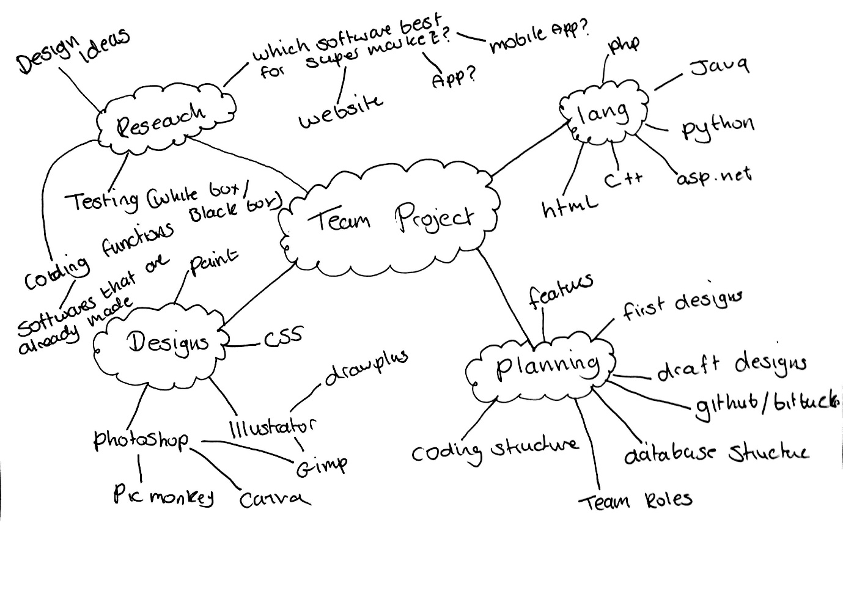

### Website Design

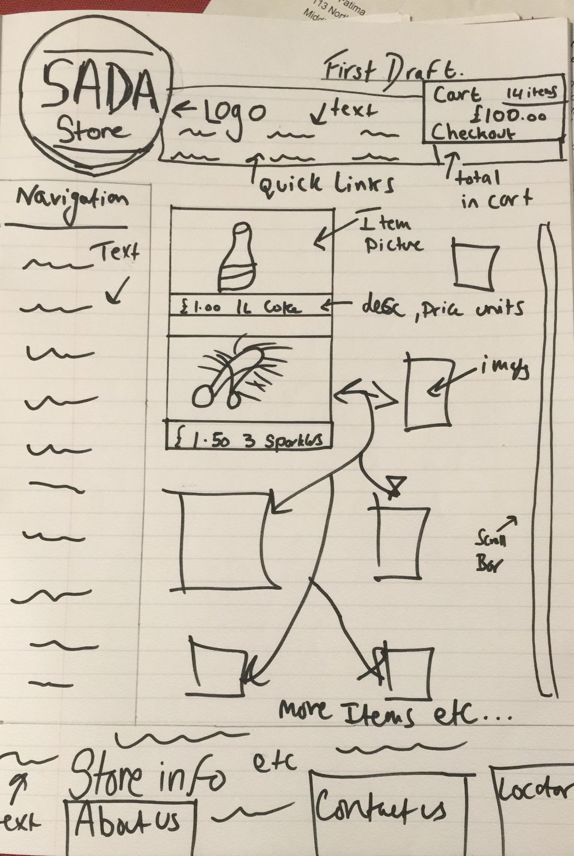

### Website Design v0.2

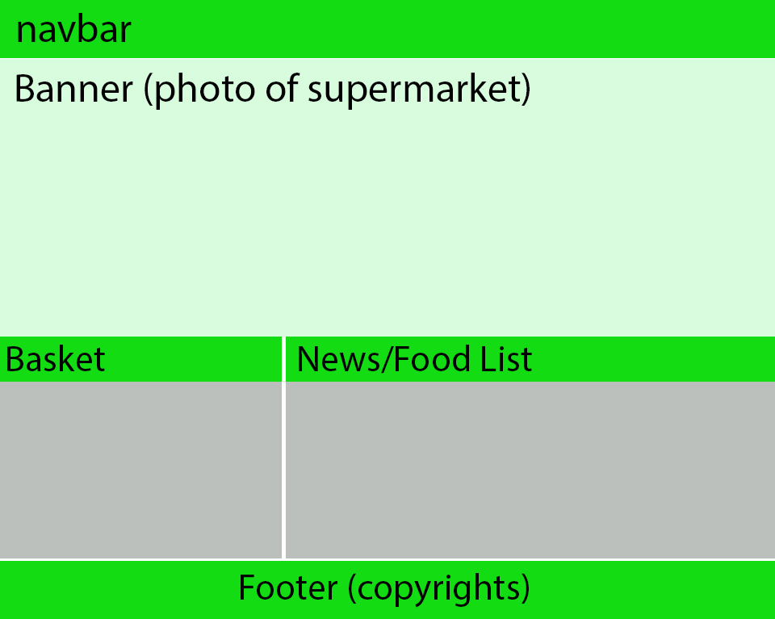

### Final Website Design

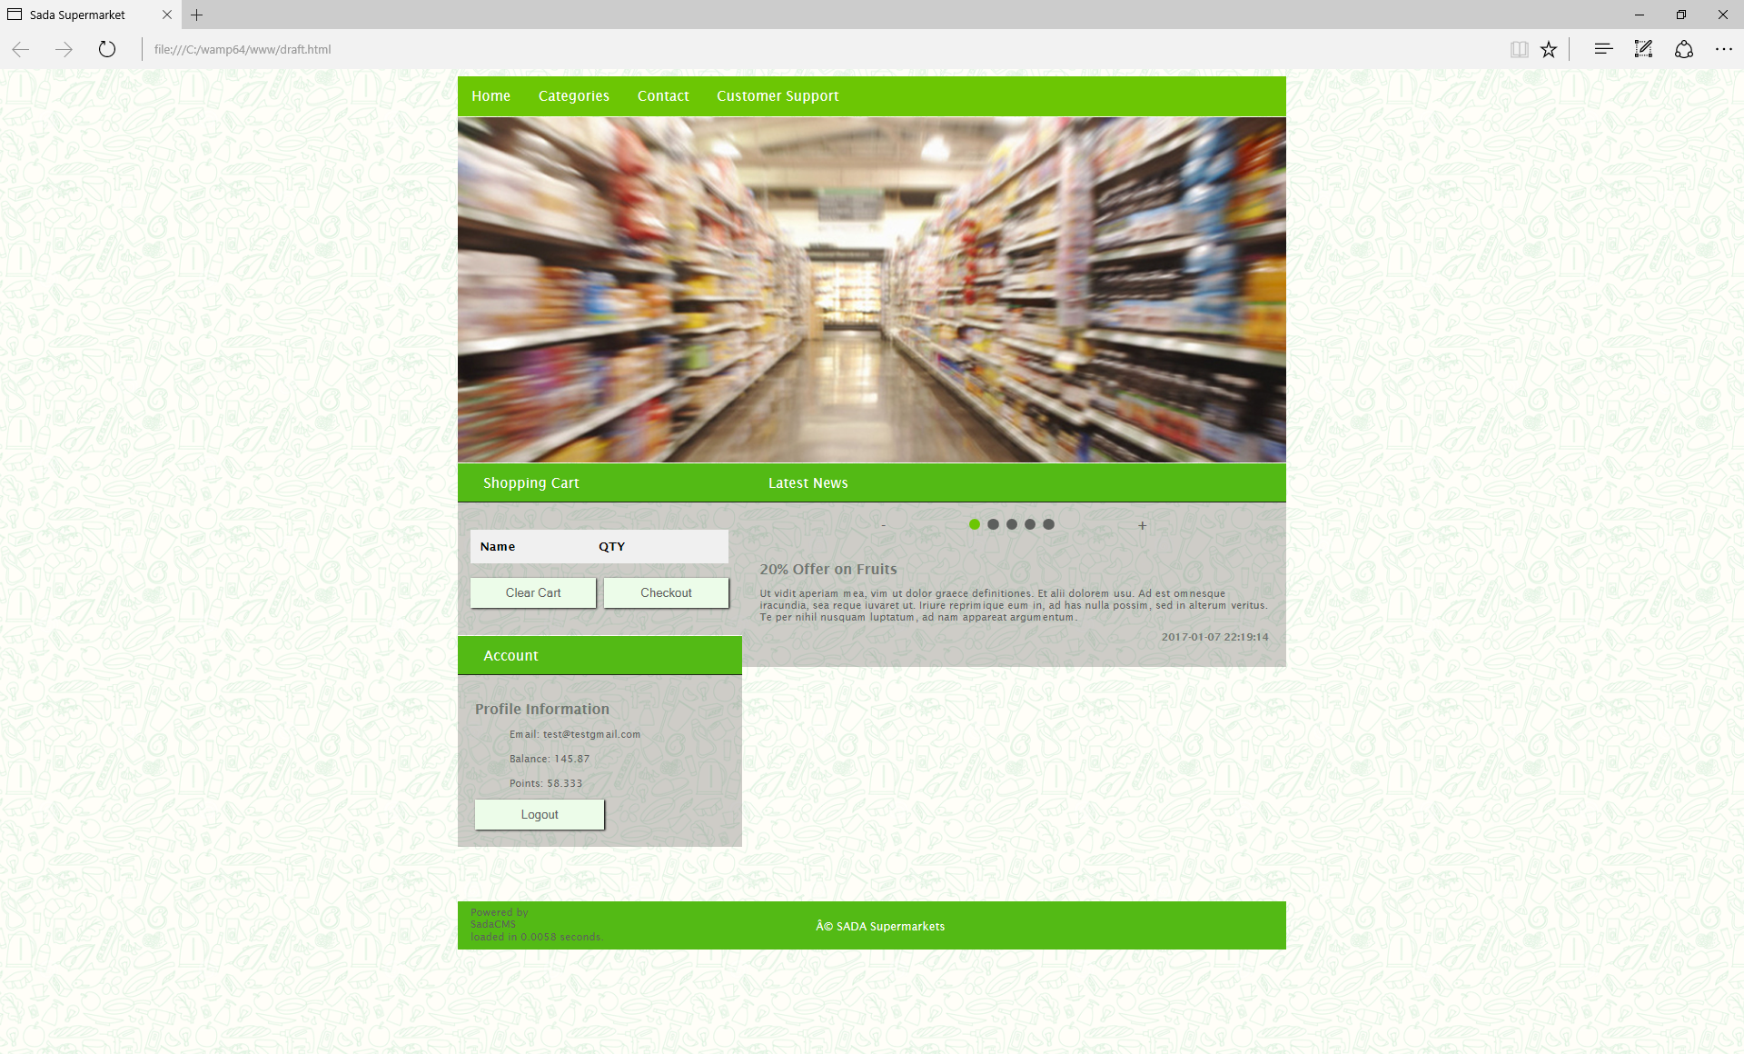

### Website Structure

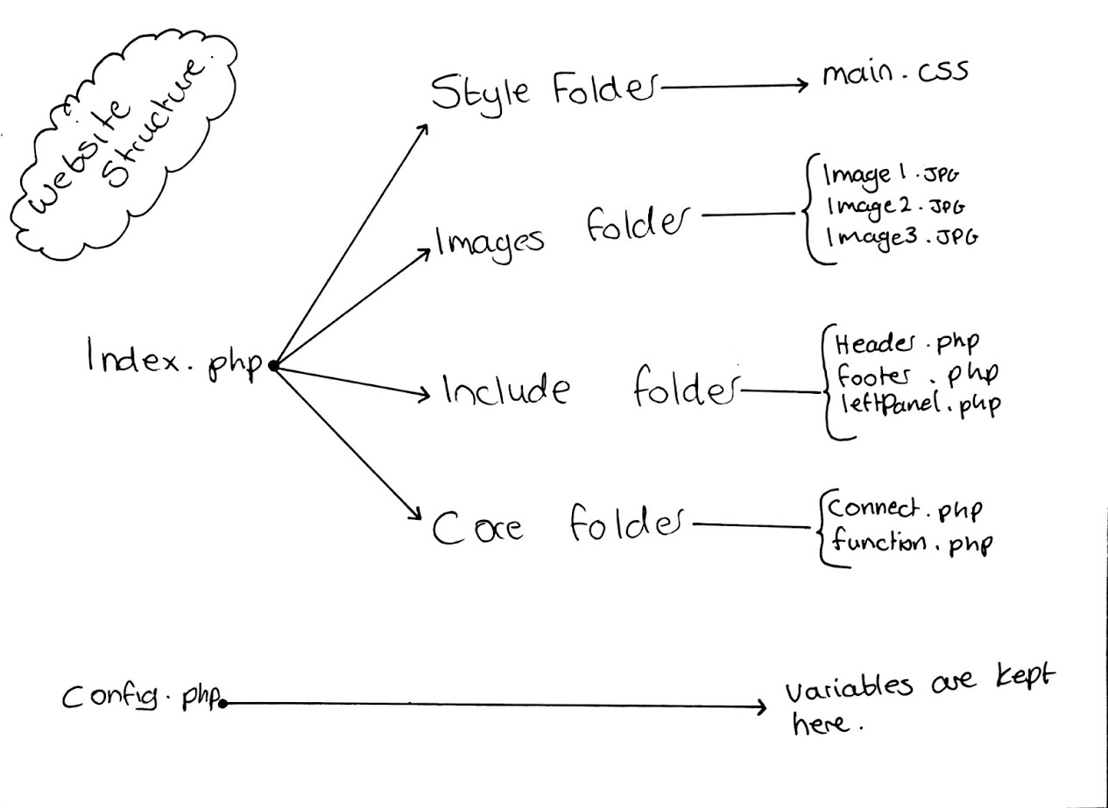

### Database Structure

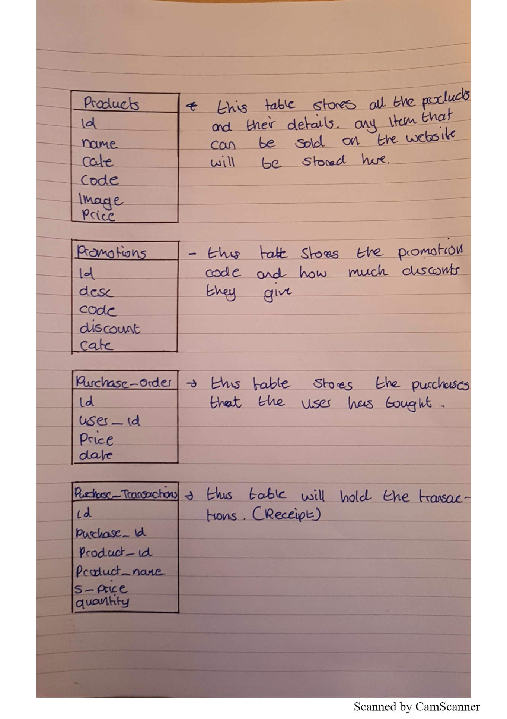

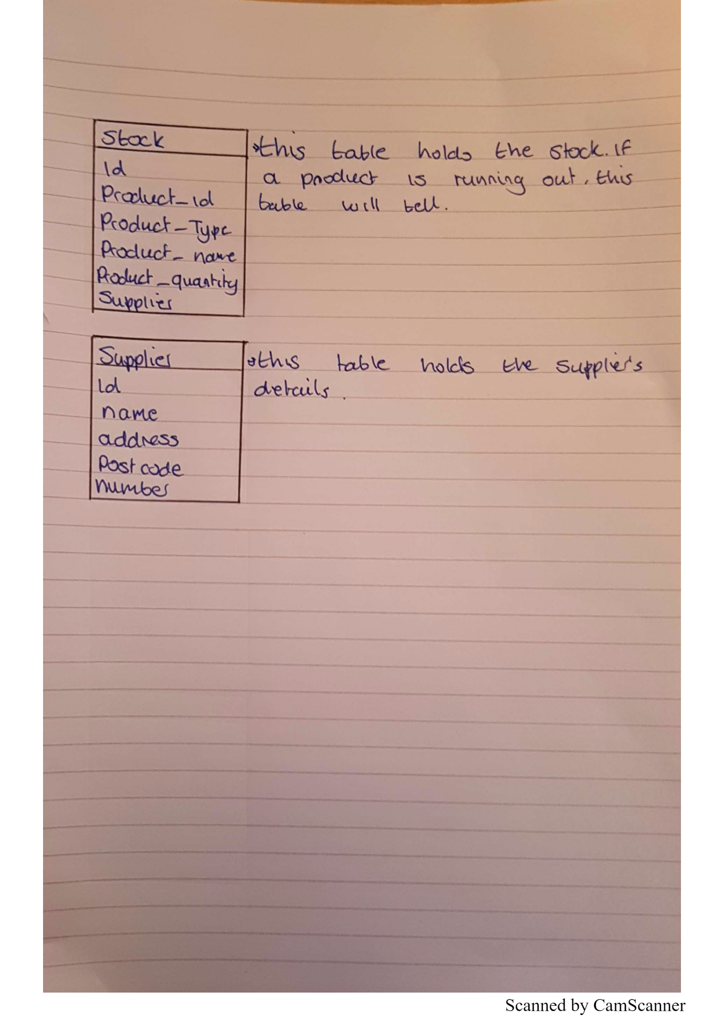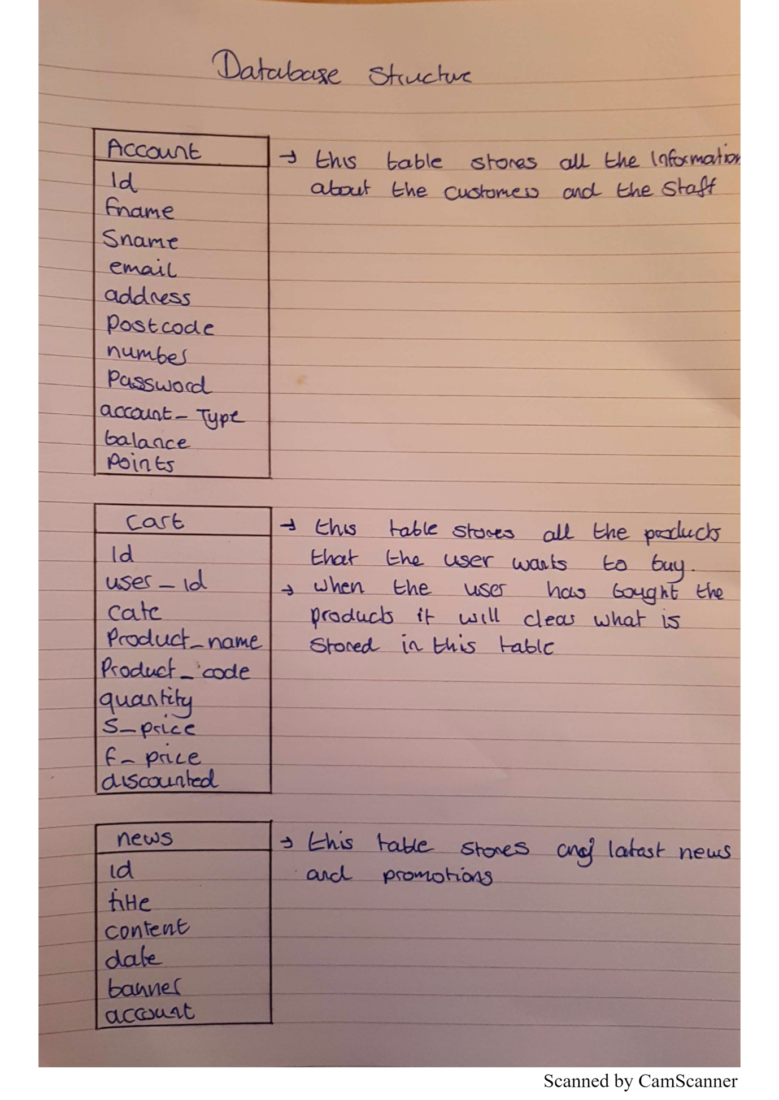

# Project Components

Describe different project components such as the Core, the payment, the marketing, the loyalty scheme and the supplier interface components. The section should start with naming different components you have developed followed by a detailed description of each component in a subsection below.

The Core was a group task therefore you are not required to name a group member for this.

## [Payment] – [Sabaa Fatani]

Should include the following:

* Brief description of the component
* Requirements for the component
* Plan/schedule for the component development
* Technical documentation (at least one use case, class diagram and activity diagram)
* Functionality achieved (you can include screen shots from the software implementation)
* Risk Register for the component
* Test plan for the component

## [Loyalty Scheme] – [Sabaa Fatani]

Should include the following:

* Brief description of the component
* Requirements for the component
* Plan/schedule for the component development
* Technical documentation (at least one use case, class diagram and activity diagram)
* Functionality achieved (you can include screen shots from the software implementation)
* Risk Register for the component
* Test plan for the component

## [Supplier] – [Akber]

Should include the following:

* Brief description of the component
* Requirements for the component
* Plan/schedule for the component development
* Technical documentation (at least one use case, class diagram and activity diagram)
* Functionality achieved (you can include screen shots from the software implementation)
* Risk Register for the component
* Test plan for the component

## [Marketing] – [Abdala Ahmed]

The purpose of marketing is to understand the “market” and the competition that you are rivalled with in hopes of finding ways to improve sales, and thus increase your profit. The requirements for this sub project include offers and promotions that must be integrated into the software solution. There is a brief plan for this component shown below.

### Marketing Plan

|  |  |  |  |  |  |
| --- | --- | --- | --- | --- | --- |
| **No:** | **Task:** | **Start Date:** | **Finish Date:** | **Task Deadline:** | **Status:** |
| 1. | Research supermarkets to get a better insight into what offers and promotion to include in the software solution. | 25/01/2017 | 30/03/2017 | 30/03/2017 |  |
| 2. | Refactor data from research to be user appropriate. | 28/01/2017 | 25/03/2017 | 31/03/2017 |  |
| 3. | Integrate the refactored data into the database. | 29/01/2017 | 27/03/2017 | 31/03/2017 |  |
| 4. | Conduct testing for the discount codes. | 20/03/2017 | 30/03/2017 | 31/03/2017 |  |
| 5. | Review content, and functions for my sub project. | 18/03/2017 | 30/03/2017 | 31/03/2017 |  |

### Risk Register

The table below shows the risk register for this component, which will give an outline of the risks that occurred in the development of my sub project as well as the impact it has had on me during the project.

|  |  |  |  |  |  |  |  |  |  |  |  |
| --- | --- | --- | --- | --- | --- | --- | --- | --- | --- | --- | --- |
| **No.** | **Rank** | **Risk** | **Description** | **Category** | **Root cause** | **Triggers** | **Potential Responses** | **Risk owner** | **Probability [low, medium, high]** | **Impact** | **Status [yes, no]** |
| R11 | 1 | Outdated/inaccurate information. | This is the research that were on the deals and offers of other supermarkets. | negative | Inconsistent research, as the project has a long deadline, research must be done consistently to gain accurate content. | Lack of commitment to research. | Immediately construct market research based on comparing the differences between the current content and previous content gained from the research, to see whether the information is up-to-date. | Abdala | M | This as a result will affect the validity of the software solution as the content may not be believable or accurate by the users of the system. | No |
| R22 | 2 | Delaying market research / inconsistency. | Market research is done, however not consistently resulting in a time gap in between each research expedition. | Negative | Disorganised plan, resulting in an unequal commitment in the assigned tasks, and thus leading to inconsistency. | Disoriented project plan, where tasks clash in terms of when they should be done. | Consult team leader on the plan, in order to devise a new one, and thus avoiding the issue from happening again. | Abdala, team leader | L | As a result, this will affect the quality of the software solution as the assigned tasks will not have had equal attention from the developer. | No |
| R33 | 3 | Defective equipment. | The equipment used were faulty, and thus preventing the developer from carrying out their task. | negative | Ineffective maintenance of the equipment, such as not cleaning the equipment etc. | Dust, water etc. Any substance that could damage electronic equipment as that is the primary equipment used for the market research. | If this risk does occur, there is the option of using the universities electronic facilities, in order to continue market research, as well as the other roles and responsibilities associated with this sub-project. | Abdala | L | As a result, it prevents the developer from carrying out effective research as they would lose access to the equipment. | No |
| R44 | 4 | Finishing the assigned tasks sooner than deadline. | The work is finished earlier than it should have been. | positive | Task was not as complicated as it seemed | Effective team work and communication. | Support other members with their tasks. | Abdala | M | Overall the software solution, would be more accurate and effective in fulfilling its purpose. | No |

### Test Plan

The test plan was to test that the discount codes are functional, which was done by means of physically using the discount codes on the online supermarket. At first I would use the discount on a product that it is not meant for, (for e.g. a fruit discount used on drinks) to see if the online supermarket responds as it should do, and the vice versa to see the opposite effect.

|  |  |  |  |
| --- | --- | --- | --- |
| **ID:** | **Task Description:** | **Predicted outcome:** | **Actual outcome:** |
| 1.1 | Check discount code functionality for the “20FRUIT” discount. | The promo-code should discount the total of the basket/shopping cart by 20%. | The total cost of the shopping cart has received a discount of 20%. |
| 1.2 | Check discount code functionality for the “50EVERY” discount. | The promo-code should discount the total of the basket/shopping cart by half (50%). | The total cost of the shopping cart has received a discount of 50%. |
| 1.3 | Check to see if the offers and promotions are automatically updated on the home page. | The offers should update automatically on its own, as it slides left. | The update occurs only if the customer clicks on the promotion. |
| 1.4 | Check to see if a discount for a specific product works only for that type of product. | A fruit discount should only work for fruit items, nothing more. | Discount only works for the assigned category (fruit, veg, meat etc.). |

# Project Documentation

This section should include documentation produced by different roles within the project team.

## [Registration & Login] – [Abdala Ahmed]

The roles and responsibilities I was assigned to do was to create the registration form as well as the login. The approach I took was I first created a table for login details in the database in order to enable the online supermarket to record the details of the customers into the database, and once recorded they would be able to login with the username and password created by the customer as the database would recognize the details and allow the customer to the online supermarket.

The following print screen shows the registration process, and how the database records the details of the customer.

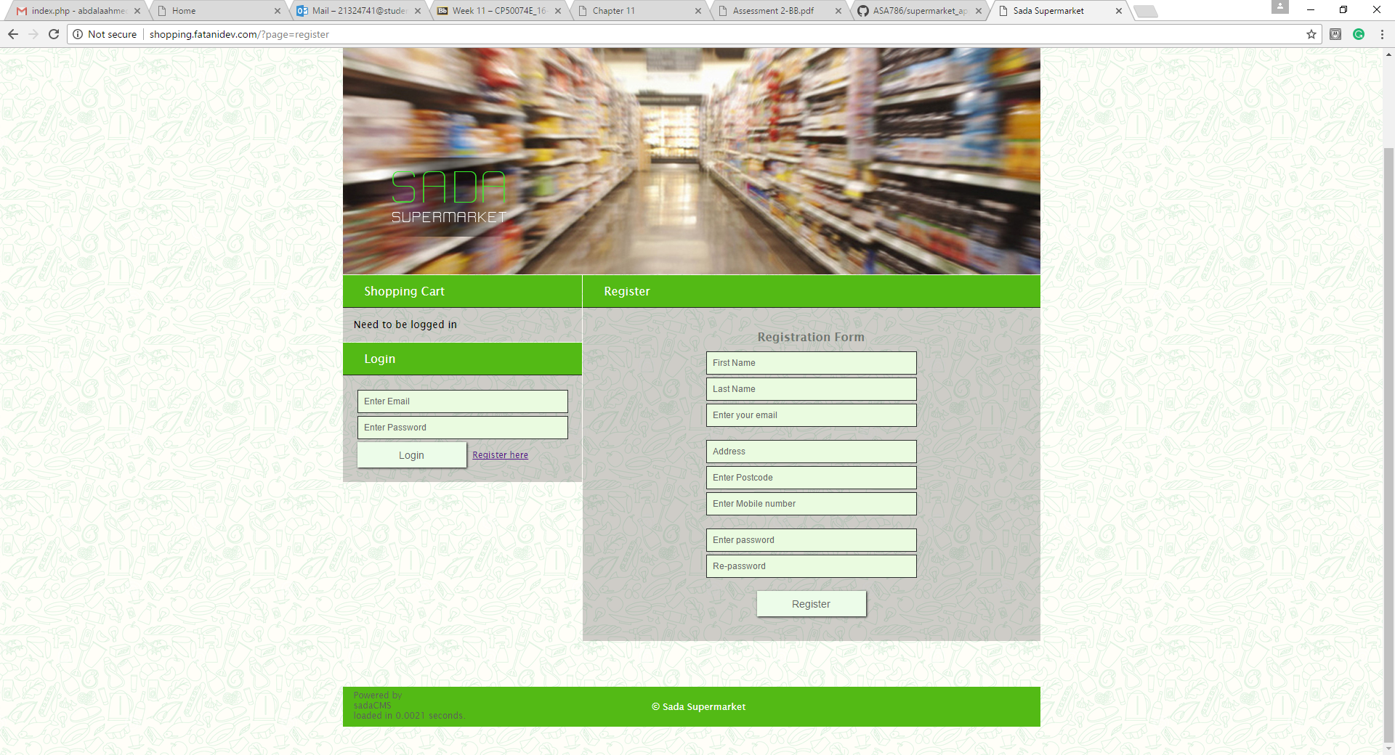

As you can see from the print screen above the registration form has a total of eight section to fill in, these include First Name, Last Name, enter your email, Address, Enter Postcode, Enter Mobile number, Enter password and Re-password. Once filled in the customer should click the “Register” button to complete the registration process.

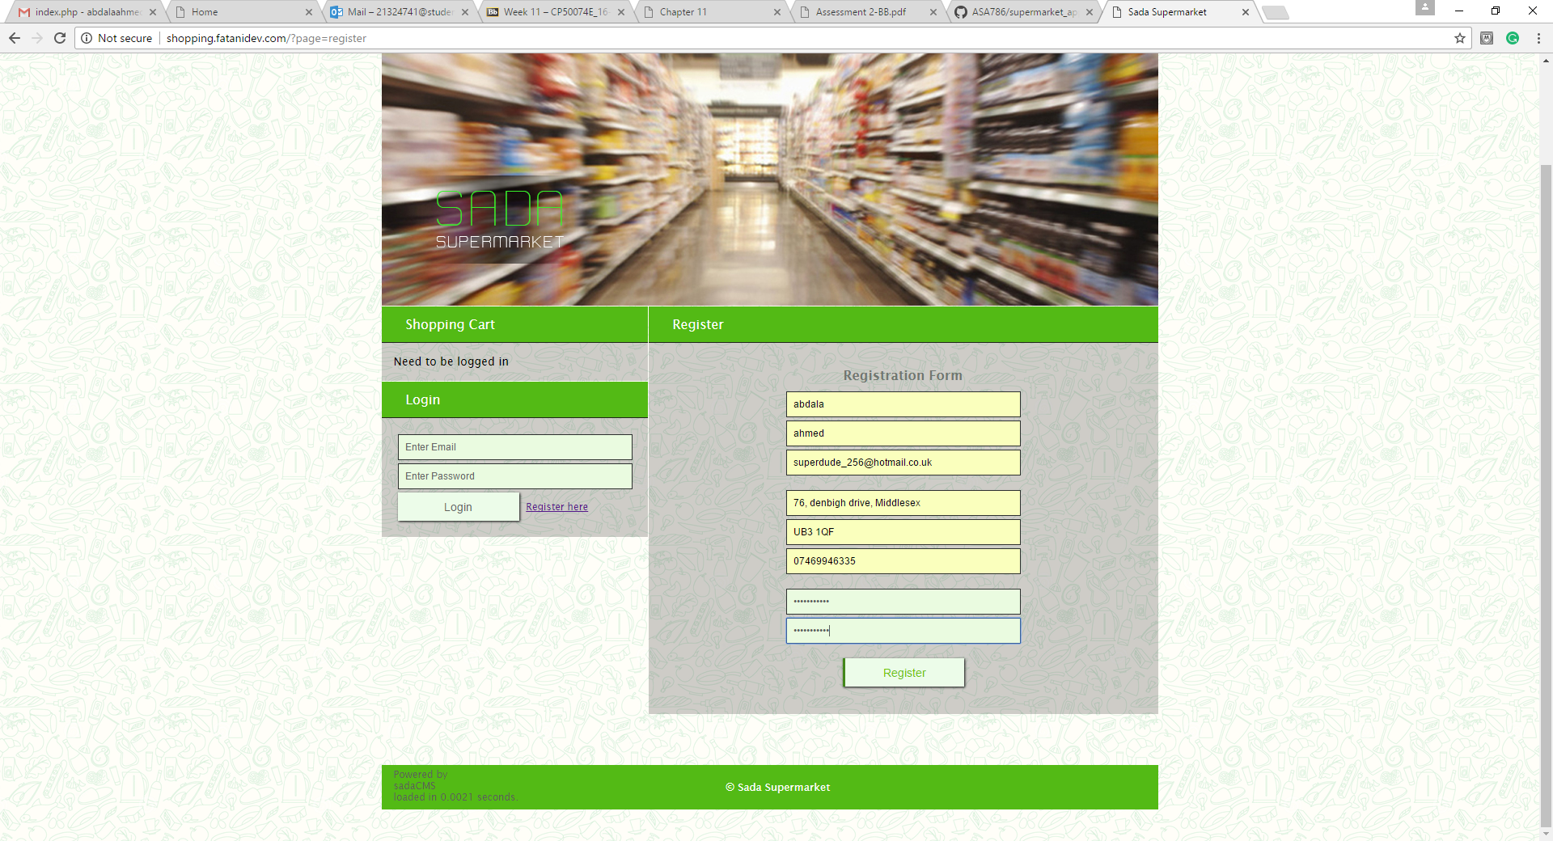

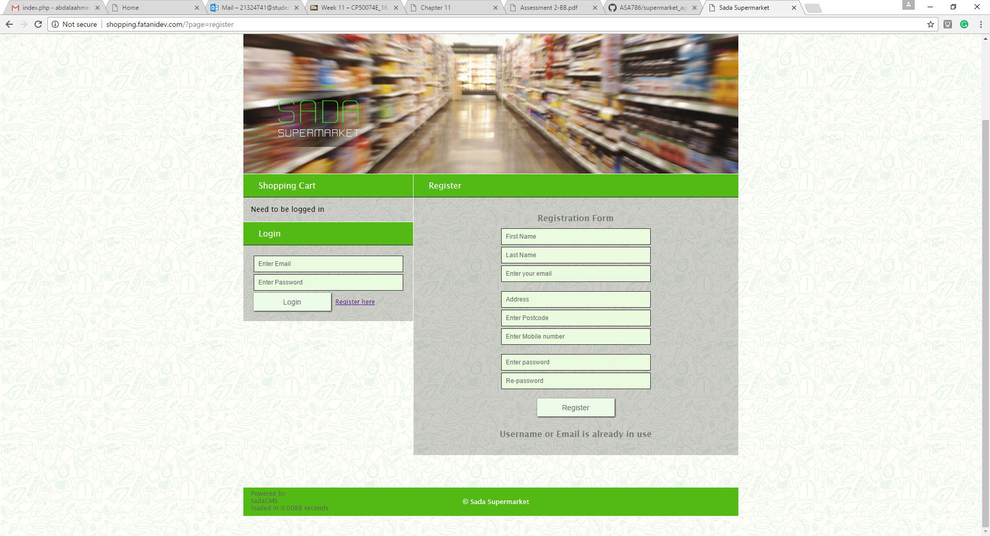The screenshot above shows that the registration form is filled in, and all that’s left to do is to click the button to record the details into the database.

As you can see from the print screen above, the registration failed as the email is already in use, reasons being because I have already registered before.

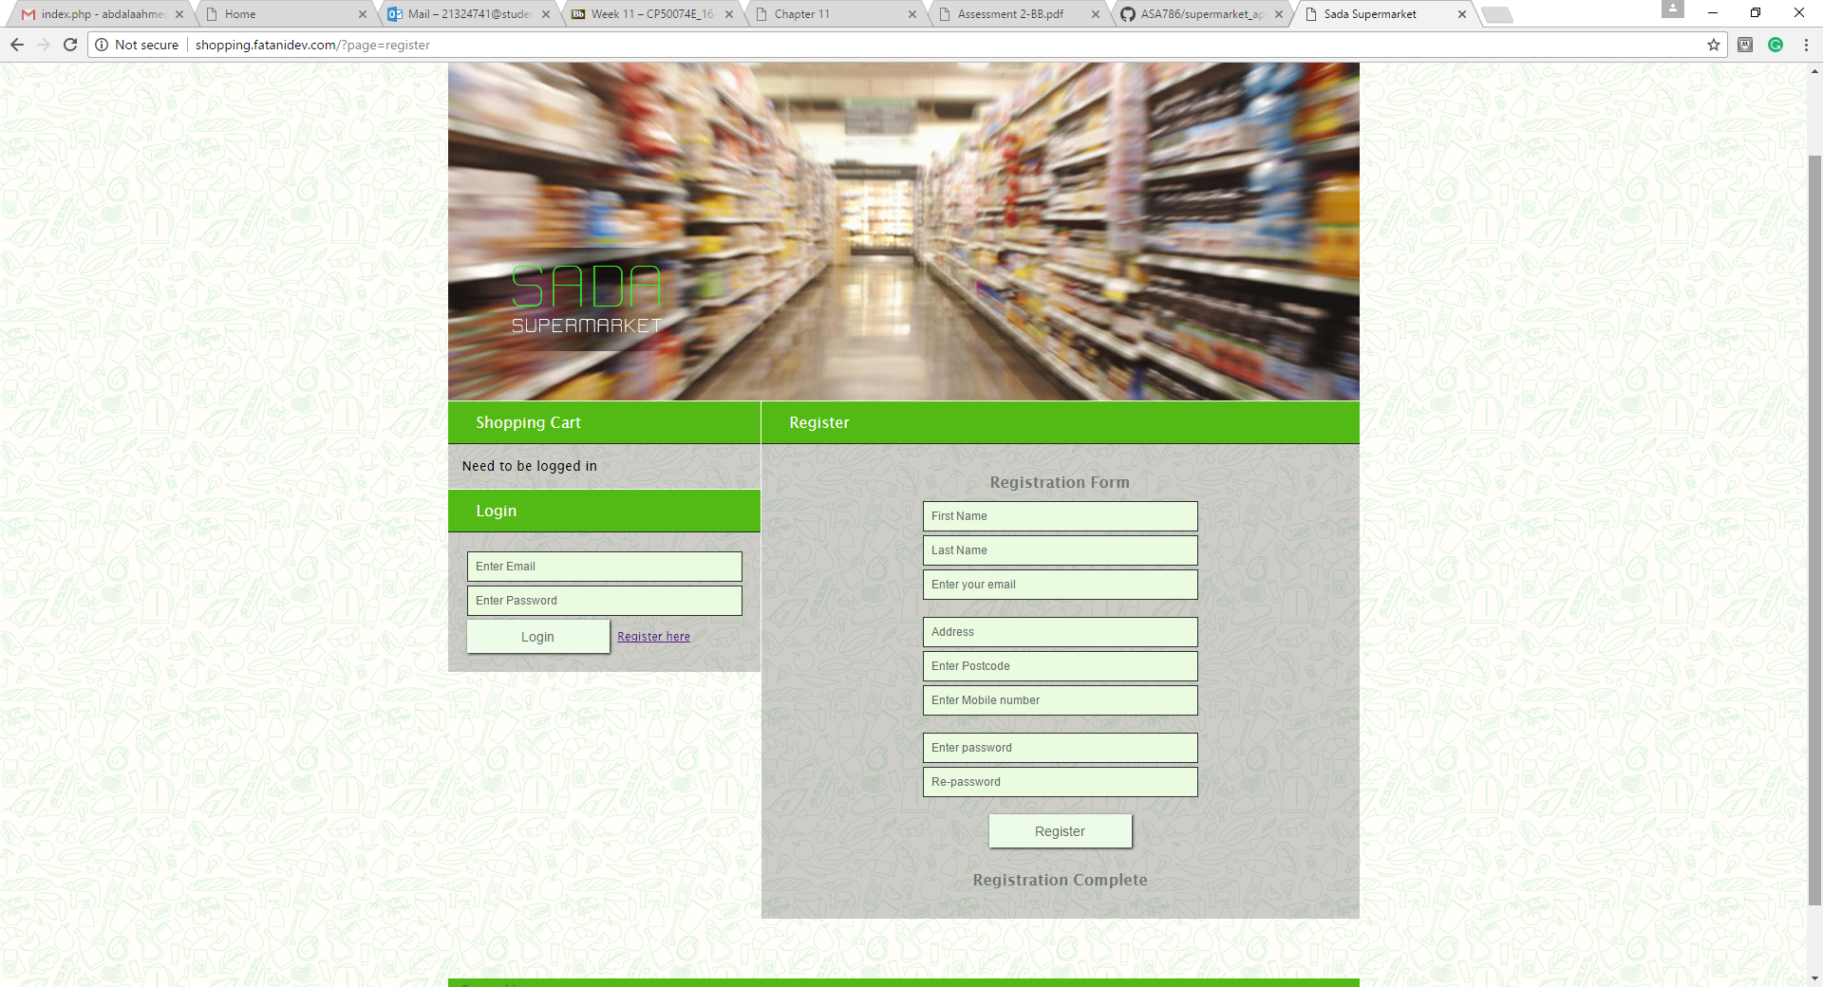

The print screen above shows what happens if a new customer uses the registration form, which gives a message saying, “Registration Complete”, which shows that the registration form is fully functional.

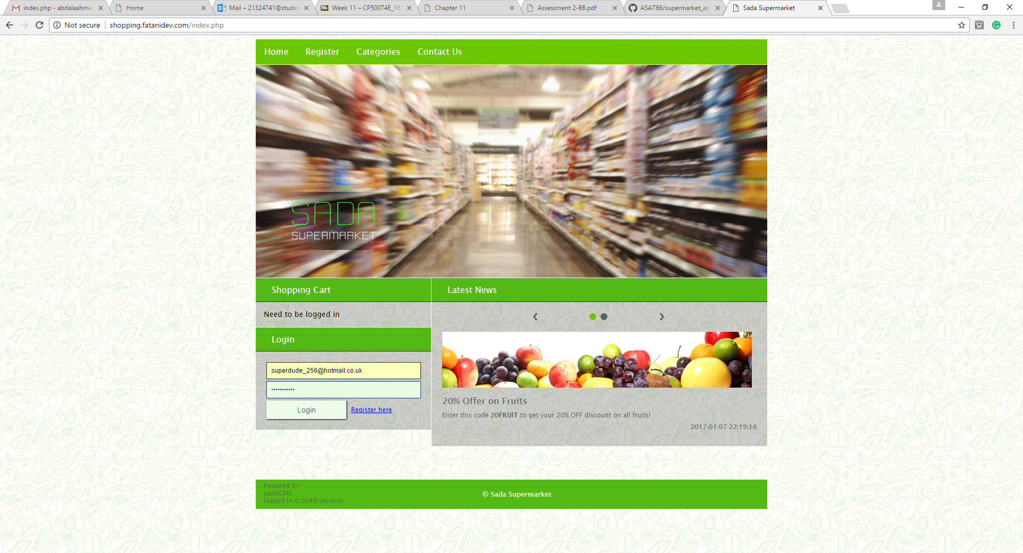

As you can from the print screen above the login details are entered in the provided boxes above, which is simply entering the email the customer used in the registration form as well as the password he/she assigned.

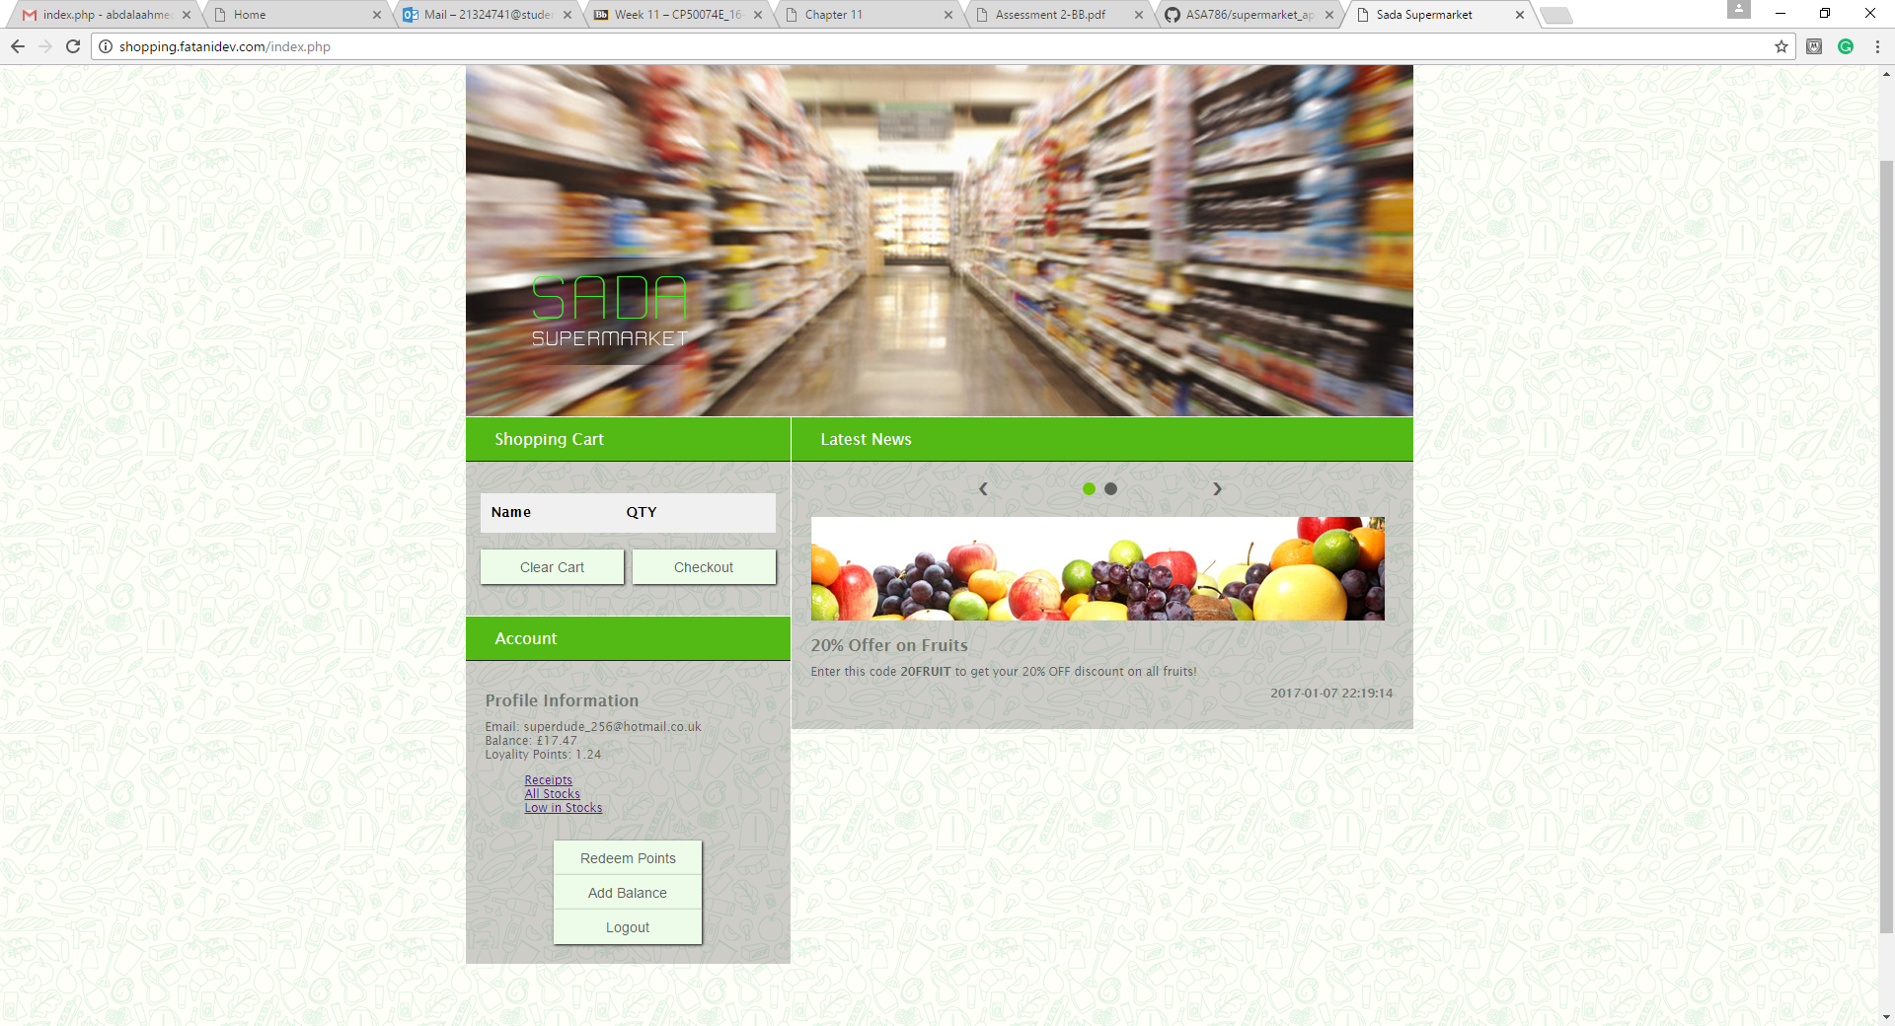

The screenshot above shows the outcome after the user has logged in with their login details. It simply displays the customers profile information, along with their balance and loyalty points.

# Group Activities

This section is expected to include the group activities you conducted to accomplish this project. These can include:

Group activities consisted of firstly creating a WhatsApp group chat, this was partially useful as this was the first main point of contact to raise any concerns or general talk. We could all get notifications and can communicate freely from where ever.

Meetings would also be done on Tuesdays between the group members to show and discuss any problems or ideas they had.

Github was the platform we choose to share all media resources and work completes and various documents.

# ConclusionReferences

List of References

# Appendix A

User Manual